

BIT4138: ADVANCED CRYPTOGRAPHY
Practical Logbook

Student Name: | WAMBUGU ELVIS
Admission Number: | BSCCS/2024/54678
Course / Class: | COMPUTER SCIENCE
Unit Code: | BIT4138
Unit Name: | Advanced Cryptography
Lecturer: | MICHAEL NYORO
Semester / Year: | SEMESTER 2 YEAR 3
Project Title: | Secure Student Report Submission System
Technologies Used: | Python, PyCryptodome, OpenSSL, VS Code
GitHub Link: | https://github.com/elvis-cdev/BIT4138-Cryptography

Table of Contents
Week 1: Cryptography Environment Setup 3
Week 2: Classical Cryptography and Cipher Design 5
Week 3: Stream Ciphers and Randomness Testing 8
Week 4: Block Cipher Design and AES 10
Week 5: Public Key Cryptography (RSA) 12
CREATIVE TASK 14
Fig 4 Report retrieval showing all layers decrypted and SHA-256 integrity check passed 15
Week 6: Hashing and Password Security 16

Week 1: Cryptography Environment Setup
Title: Installation and Configuration of Cryptography Development Environment
Fig 1: Python version confirmed in terminal — python --version output visible
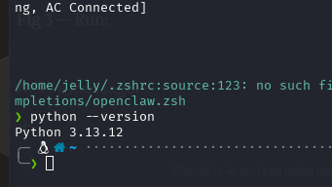

Fig 2: pip install cryptography pycryptodome command running successfully
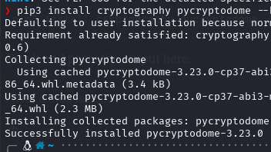

Fig 3: openssl version command confirming OpenSSL is installed and configured

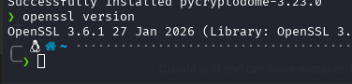

Fig 4: Simple Python encryption test script running without errors
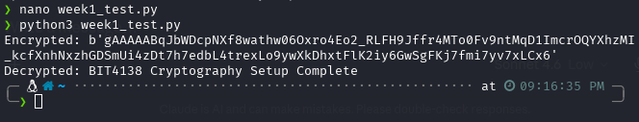

Fig 5: GitHub repository created showing first commit and README file
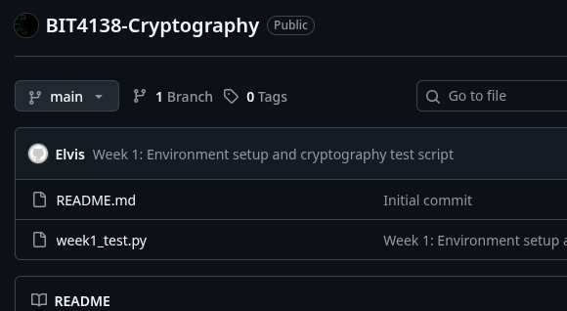

My Reflection
started by setting up my environment on Linux. Installed Python, VS Code, OpenSSL and the cryptography libraries. Ran a simple test script to confirm encryption was working. Also created a GitHub repo and pushed my first commit. Took a while but everything is working now

Week 2: Classical Cryptography and Cipher Design
Title: Implementation of Classical Encryption Algorithms

Fig 1: Caesar Cipher Python script showing the shift encryption function
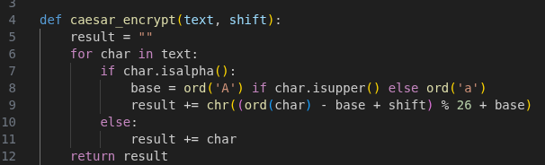

Fig 2: Vigenère Cipher encryption output with keyword and ciphertext visible

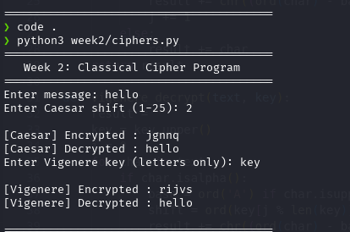

Fig 3: Program running and producing correct encryption and decryption results


Fig 4: User input validation handling invalid or empty inputs correctly
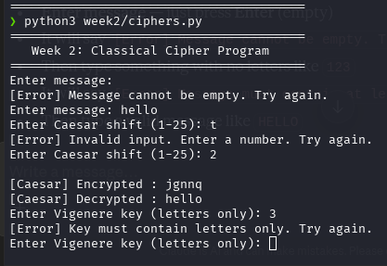

Fig 5: Test results confirming both ciphers encrypt and decrypt correctly
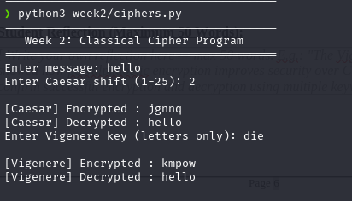

My Reflection
I wrote a Caesar and Vigenere cipher program in Python. The Caesar one shifts letters by a number you choose and Vigenere uses a keyword. I also added input validation so empty or wrong inputs show an error. Both ciphers encrypted and decrypted correctly which was cool to see.

Week 3: Stream Ciphers and Randomness Testing
Title: Implementation of Stream Cipher Systems and Random Sequence Analysis

Fig 1: LFSR generator Python script producing a binary sequence output
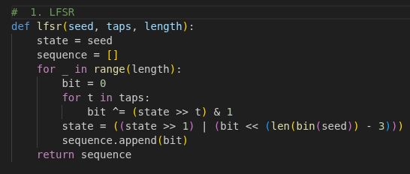

Fig 2: Pseudorandom sequence of 100+ bits generated with seed value shown
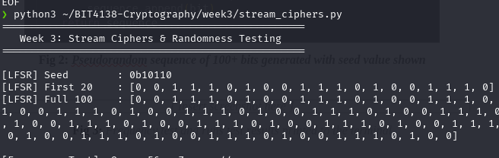

Fig 3: Frequency test and runs test results printed to the terminal
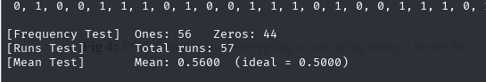

Fig 4: RC4 stream cipher encrypting a text string using a secret key
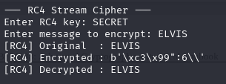

Fig 5: Performance comparison showing encryption speed test results
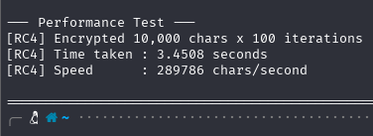

My Reflection
I implemented an LFSR generator and RC4 stream cipher in Python. The LFSR produced a 100 bit pseudorandom sequence which I tested using frequency, runs and mean tests. RC4 encrypted and decrypted text correctly using a secret key. The performance test showed how fast stream encryption actually is.

Week 4: Block Cipher Design and AES
Title: Advanced Encryption Standard (AES) and Block Cipher Operations

Fig 1: AES encryption Python script implemented using PyCryptodome library
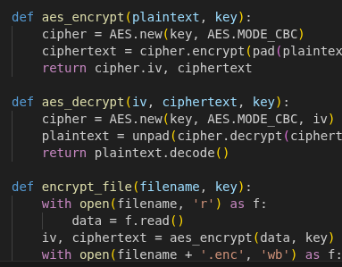

Fig 2: AES key generation output showing a 256-bit symmetric key
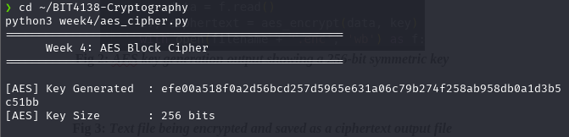

Fig 3: Text file being encrypted and saved as a ciphertext output file
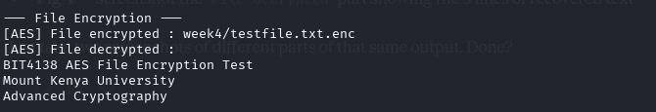

Fig 4: Successful decryption recovering the original plaintext from ciphertext

Fig 5: Performance test showing encryption and decryption execution speed
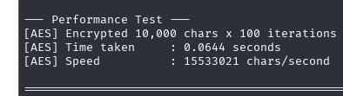

My Reflection
I implemented AES encryption in Python using PyCryptodome. Generated a 256-bit key and used it to encrypt both a text message and a file. Decryption successfully recovered the original content. The performance test showed AES is very fast even for large data which makes sense for a block cipher.

Week 5: Public Key Cryptography (RSA)
Title: Implementation of RSA Encryption and Key Management

Fig 1: RSA 2048-bit key pair generation showing public and private keys output
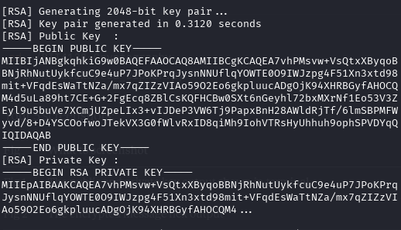

Fig 2: Message being encrypted using the RSA public key
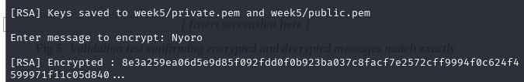

Fig 3: Ciphertext decrypted using the private key recovering the original message
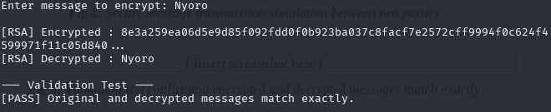

Fig 4: Secure message transmission simulation between two parties
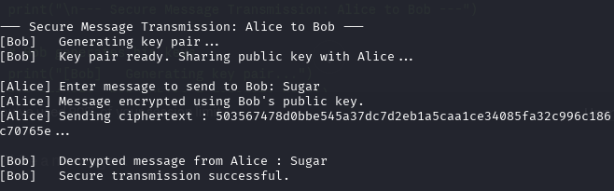

Fig 5: Validation test confirming encrypted and decrypted messages match exactly
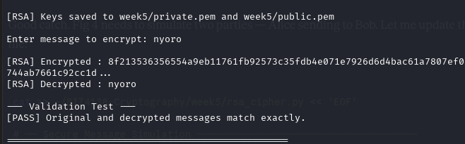

My Reflection
I implemented RSA encryption using 2048-bit keys in Python. Generated public and private key pairs, encrypted a message using the public key and decrypted it using the private key. Simulated secure transmission between Alice and Bob. The validation test confirmed the original and decrypted messages matched perfectly

CREATIVE TASK
Description:

For my creative task I built a Secure Student Report Submission System. It combines everything we covered passwords are hashed using SHA-256, reports encrypted with AES, the AES key protected using RSA, filename encoded with Caesar cipher and metadata encrypted with RC4. I wanted to show how real secure systems actually work.

Evidences

fig 1 Secure Student Report Submission System main menu displayed in terminal

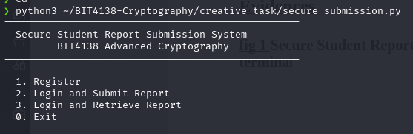

fig 2
Student registration showing SHA-256 hashed password and RSA key pair generated
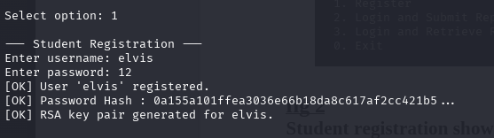

fig 3:Report submission showing AES encryption, RSA key protection, Caesar encoded filename and RC4 metadata encryption
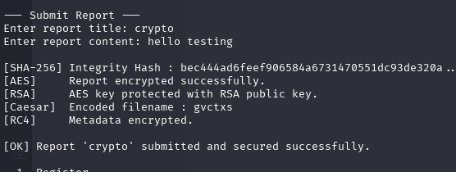

Fig 4 Report retrieval showing all layers decrypted and SHA-256 integrity check passed

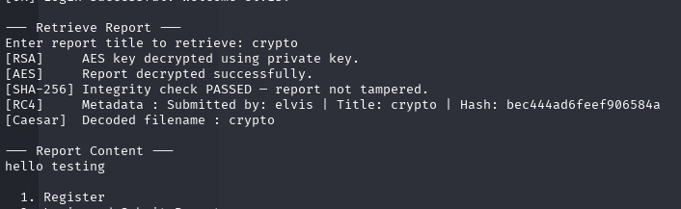

Week 6: Hashing and Password Security
Title: Implementation of Secure Hash Functions and Authentication

Fig 1: SHA-256 hash generated for a sample text input string
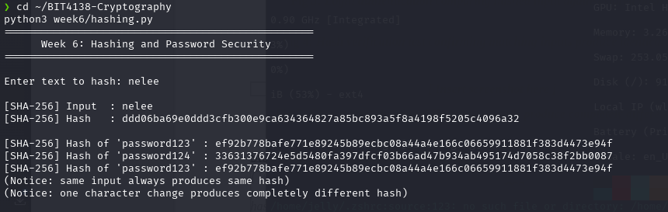

Fig 2: Password hashing system storing hashed values instead of plaintext
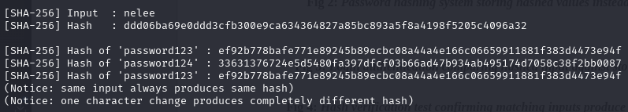

Fig 3: Login authentication comparing hashed input against stored hash value
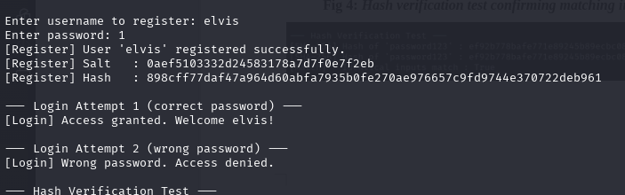

Fig 4: Hash verification test confirming matching inputs produce identical hashes
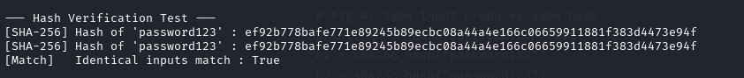

Fig 5: Security test showing different passwords produce completely different hashes
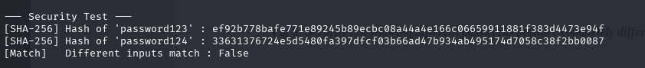

My Reflection
I implemented SHA-256 hashing in Python to securely store passwords. Passwords are salted before hashing so even identical passwords produce different hashes. The login system compares hashed inputs against stored values instead of plain text. I also confirmed that same input always produces the same hash and different inputs produce completely different hashes.

